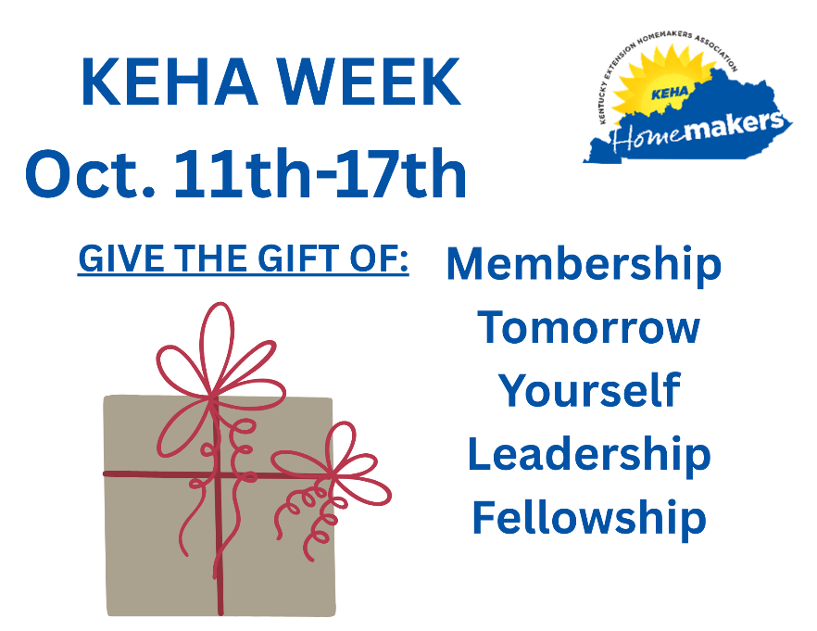


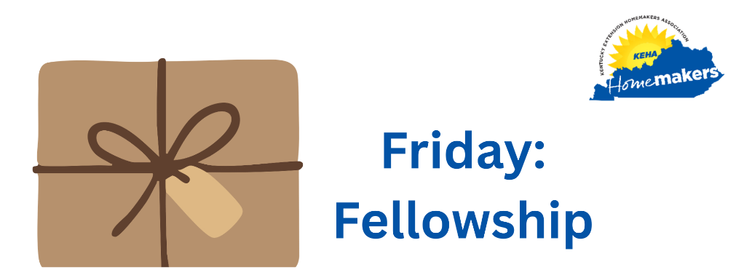

To claim your free gift membership, cut on the dotted and return this form to: XXXX County Extension Office
100 Any Street
Anytown, Kentucky 4XXXX

Name:

Address:

City: State: Zip Code:

Phone number: email:

Gift membership given by:

Club name:

To claim your free gift membership, cut on the dotted and return this form to: XXXX County Extension Office
100 Any Street
Anytown, Kentucky 4XXXX

Name:

Address:

City: State: Zip Code:

Phone number: email:

Gift membership given by:

Club name:

